**Solution 4:**

**Validate JWT Token Expiry and Handle Unauthorized Access Scenario:**

**You want to handle expired or invalid tokens gracefully.**

**Steps: 1. Configure JWT bearer events.**

**2. Return custom messages for unauthorized access.**

**//Program.cs:**

using Microsoft.AspNetCore.Authentication.JwtBearer;

using Microsoft.IdentityModel.Tokens;

using Microsoft.OpenApi.Models;

using System.IdentityModel.Tokens.Jwt;

using System.Text;

var builder = WebApplication.CreateBuilder(args);

builder.Services.AddAuthentication(options =>

{

    options.DefaultAuthenticateScheme = JwtBearerDefaults.AuthenticationScheme;

    options.DefaultChallengeScheme = JwtBearerDefaults.AuthenticationScheme;

})

.AddJwtBearer(options =>

{

    options.TokenValidationParameters = new TokenValidationParameters

    {

        ValidateIssuer = true,

        ValidateAudience = true,

        ValidateLifetime = true,

        ValidateIssuerSigningKey = true,

        ValidIssuer = builder.Configuration["Jwt:Issuer"],

        ValidAudience = builder.Configuration["Jwt:Audience"],

        IssuerSigningKey = new SymmetricSecurityKey(

            Encoding.UTF8.GetBytes(builder.Configuration["Jwt:Key"]!))

    };

    options.Events = new JwtBearerEvents

    {

        OnAuthenticationFailed = async context =>

        {

            context.Response.StatusCode = 401;

            context.Response.ContentType = "application/json";

            var message = context.Exception is SecurityTokenExpiredException

                ? "{\"error\": \"Token has expired.\"}"

                : "{\"error\": \"Invalid token.\"}";

            await context.Response.WriteAsync(message);

        }

    };

});

builder.Services.AddAuthorization();

builder.Services.AddControllers();

builder.Services.AddEndpointsApiExplorer();

builder.Services.AddSwaggerGen(options =>

{

    options.SwaggerDoc("v1", new OpenApiInfo { Title = "JwtAuthDemo", Version = "v1" });

    options.AddSecurityDefinition("Bearer", new OpenApiSecurityScheme

    {

        Name = "Authorization",

        Type = SecuritySchemeType.ApiKey,

        Scheme = "Bearer",

        BearerFormat = "JWT",

        In = ParameterLocation.Header,

        Description = "Enter 'Bearer' followed by your token. Example: `Bearer abc123...`"

    });

    options.AddSecurityRequirement(new OpenApiSecurityRequirement

    {

        {

            new OpenApiSecurityScheme

            {

                Reference = new OpenApiReference

                {

                    Type = ReferenceType.SecurityScheme,

                    Id = "Bearer"

                }

            },

            Array.Empty<string>()

        }

    });

});

vår app = builder.Build();

app.UseSwagger();

app.UseSwaggerUI();

app.UseHttpsRedirection();

app.UseAuthentication();

app.UseAuthorization();

app.MapControllers();

app.Run();

**Output:**

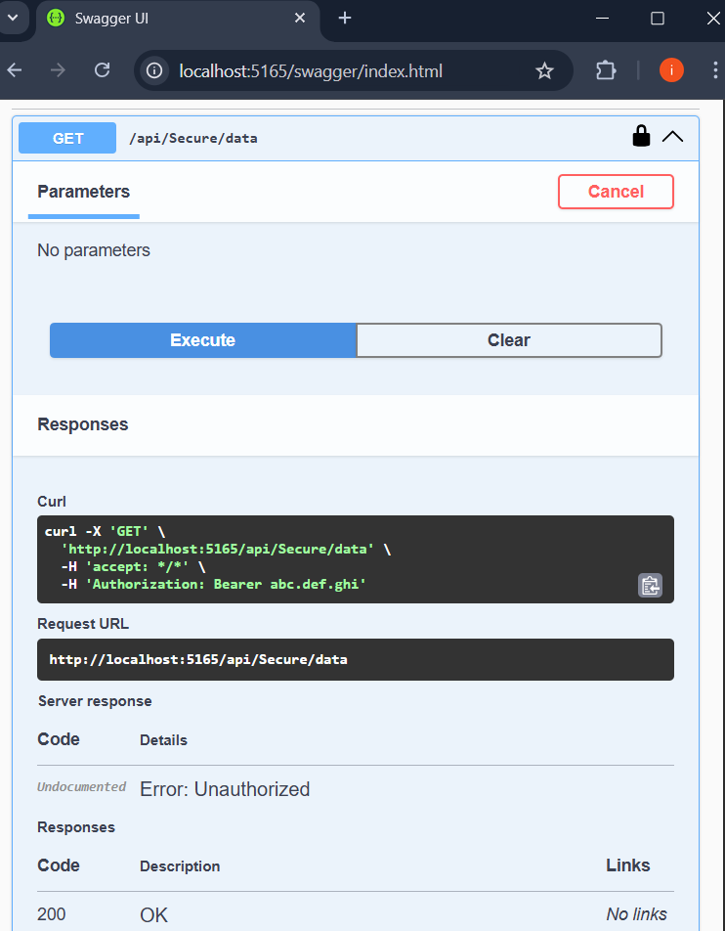

**Solution 5:**

1. Verify if master is in clean state.
2. List out all the available branches.
3. Pull the remote git repository to the master
4. Push the changes, which are pending from **“Git-T03-HOL_002”** to the remote repository.
5. Observe if the changes are reflected in the remote repository.

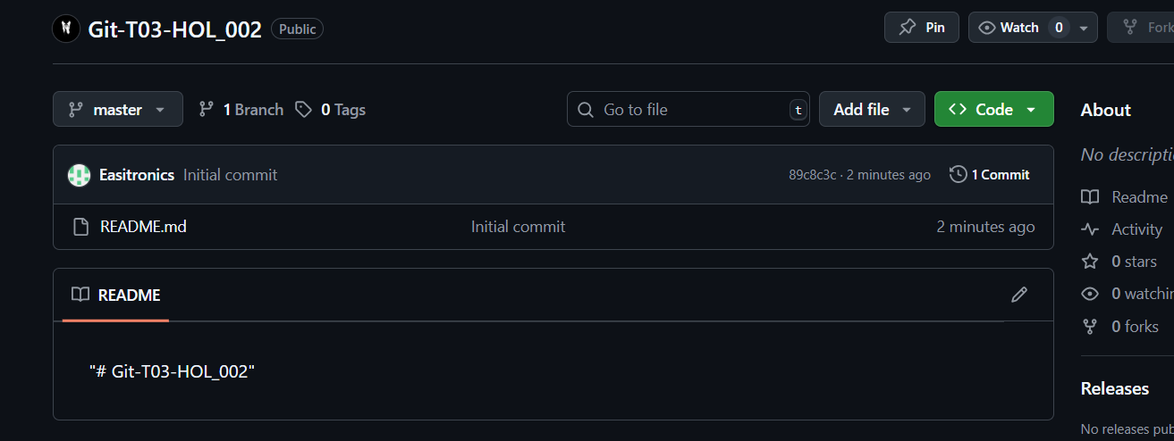

**OUTPUT:**

